
Arduino Basic Kit

What is an Arduino Basic Kit ?

An Arduino basic kit is a beginner-friendly set of components built around the Arduino Uno to learn electronics and programming.It includes essential parts like a breadboard, jumper wires, LEDs, resistors, and simple sensors.It is used to create basic projects such as LED blinking, sensor-based systems, and small automation circuits.

Why do we need an Arduino Kit?
- To Learn Electronics & Programming Basics:
Students understand concepts like current flow, circuits, and how components work using an Arduino Uno.
- Hands-on Learning:
It allows students to build real projects instead of just theory, helping them gain practical experience through experiments.
- To Build Simple Projects:
With the kit, users can create LED circuits, sensor-based systems, and small automation projects.
- Improves Problem-Solving Skills:
While working on projects, students debug errors, think logically, and improve analytical thinking.
- Prepares for Advanced Technology:
It forms a strong base for robotics, embedded systems, and future careers in engineering and technology.
Safety Instructions
- Use correct voltage (5V USB or 7–12V input) for the Arduino Uno
- Always check connections before powering the circuit
- Avoid short circuits on the breadboard
- Use resistors with LEDs to prevent damage
- Turn OFF power before changing connections
- Do not touch exposed wires or pins unnecessarily
- Keep components away from water and moisture
- Disconnect power if any component overheats
- Use good quality jumper wires and components
- Work on a clean, non-metallic surface

Kit Components Overview

1. Arduino Uno R3:Arduino Uno R3 is a microcontroller board used to control electronic projects.It reads input signals from sensors and processes them using a programmed code.Based on the logic, it gives output to devices like LEDs, motors, or displays.It is widely used for learning embedded systems and prototyping.

2. USB Cable: A USB cable connects the Arduino board to a computer.It is used to upload programs written in the Arduino IDE.The cable also supplies power to the board during development.It helps in serial communication for debugging and monitoring.

3. Breadboard:A breadboard is used to build electronic circuits without soldering.It contains internal metal strips that connect components easily.It allows quick changes and testing of circuits safely.It is very useful for beginners and prototyping projects.

4. Jumper Wires:Jumper wires are used to make connections between components.They are available in male-to-male, male-to-female, and female-to-female types.They help organize circuits neatly on a breadboard.
They are essential for flexible and temporary wiring.

5. Resistors Kit: Resistors are used to control the flow of electric current.They protect sensitive components like LEDs from excess current.Each resistor has a specific value measured in ohms.They are fundamental components in almost every circuit.

6. LEDs: LEDs are electronic components that emit light when powered.They are commonly used as indicators in circuits.Different colors represent different signals or statuses.They are energy-efficient and widely used in electronics.

7. RGB LED: An RGB LED contains red, green, and blue LEDs in one package.
By adjusting the intensity of each color, many colors can be produced.
It is controlled using PWM signals from Arduino.
It is used in decorative lighting and visual effects projects.

8. Push Buttons:Push buttons are simple input devices used to control circuits.They complete the circuit when pressed and break it when released.They are used in projects like counters and switches.They provide user interaction with the system.

9. Potentiometer (10kΩ):A potentiometer is a variable resistor used to adjust voltage.It allows smooth control of output like brightness or speed.It sends analog input values to the Arduino.It is widely used in tuning and control applications.

10. Buzzer: A buzzer is a sound-producing device used in circuits.It generates sound when voltage is applied.It is used in alarms, notifications, and alerts.There are active and passive types based on operation.

11. Ultrasonic Sensor (HC-SR04): This sensor measures distance using ultrasonic waves.It sends sound waves and receives the reflected signal.The time taken is used to calculate distance. It is widely used in obstacle detection systems.

12. Temperature Sensor (DHT11): The DHT11 measures both temperature and humidity. It provides digital output that is easy to read.It is commonly used in weather monitoring systems.It is simple and suitable for beginner projects.

13. LDR (Light Sensor): An LDR detects the intensity of light.Its resistance changes based on light exposure.It is used in automatic lighting systems.It helps in energy-saving applications.

14. IR Sensor Module: An IR sensor detects objects using infrared radiation.It works by emitting and receiving IR signals.It can detect nearby obstacles easily.
It is widely used in robotics and automation.

15. PIR Motion Sensor:A PIR sensor detects motion by sensing heat changes.It responds to infrared radiation from humans or animals.It is commonly used in security systems.It helps in automatic lighting and alarms.

16. Soil Moisture Sensor: This sensor measures the moisture level in soil.It helps determine whether soil is dry or wet.It is used in automatic irrigation systems. It improves efficient water usage.

17. Gas Sensor (MQ-2): MQ-2 detects gases like LPG, smoke, and methane.It provides analog output based on gas concentration.It is used in gas leakage detection systems.It helps ensure safety in homes and industries.

18. Sound Sensor:A sound sensor detects sound intensity in the environment.It converts sound waves into electrical signals.It is used in clap-based control systems.It helps in sound-activated automation.

19. Rain Drop Sensor:This sensor detects the presence of rain or water.It works based on conductivity changes on its surface.It is used in rain alarms and automatic systems.It is useful in weather monitoring applications.

20. Touch Sensor:A touch sensor detects human touch using capacitance.It works without physical pressing like a button.It provides a modern input method.It is used in smart control systems.

21. Water Pump: A water pump moves water using electrical energy.It is used in irrigation and water circulation systems.It can be controlled using a relay or driver.It is essential in automation projects.

22. Water Flow Sensor: This sensor measures the rate of water flow.It generates pulses when water flows through it.The Arduino calculates flow rate from these pulses.It is used in water monitoring systems.

23. Relay Module: A relay is an electrically controlled switch.It allows low-power Arduino to control high-power devices.It provides safety through electrical isolation.It is used in home automation systems.

24. Servo Motor (SG90): A servo motor rotates to a specific angle.It is controlled using PWM signals.It provides precise movement control.It is used in robotics and automation.

25. DC Motor: A DC motor converts electrical energy into motion.It rotates continuously when powered.Speed depends on voltage supplied.It is used in fans, wheels, and machines.

26. Fan Module: A fan module produces airflow using a motor.It is used for cooling electronic components.It can be controlled using Arduino signals.It is useful in temperature-based projects.

27. 16x2 LCD Display:This display shows 16 characters in 2 rows.It is used to display sensor data and messages.It works with Arduino using simple libraries.It is widely used in embedded systems.

28. 7-Segment Display: A 7-segment display shows numbers using LED segments.Each segment lights up to form digits.It is used in counters and digital displays.It is simple and easy to interface.

29. 9V Battery + Clip: A 9V battery provides portable power supply.The clip helps connect it safely to circuits.It allows Arduino to work without a computer It is useful for standalone projects.

Project:
- LED Blinking

Components
- Arduino Uno
- LED
- 220Ω Resistor
- Breadboard
- Jumper Wires
Connections
- Arduino Pin 13 → Resistor → LED Anode (long leg)
- LED Cathode (short leg) → GND
- Breadboard used for easy connections
- Orange wire = Pin 13 (signal)
- Black wire = GND
Code
void setup() {
pinMode(13, OUTPUT);
}

void loop() {
digitalWrite(13, HIGH); // LED ON
delay(1000); // 1 second
digitalWrite(13, LOW); // LED OFF
delay(1000); // 1 second
}

Working
- Arduino sends HIGH signal → LED turns ON
- Arduino sends LOW signal → LED turns OFF
- This repeats continuously → LED blinks every 1 second
Reference Image

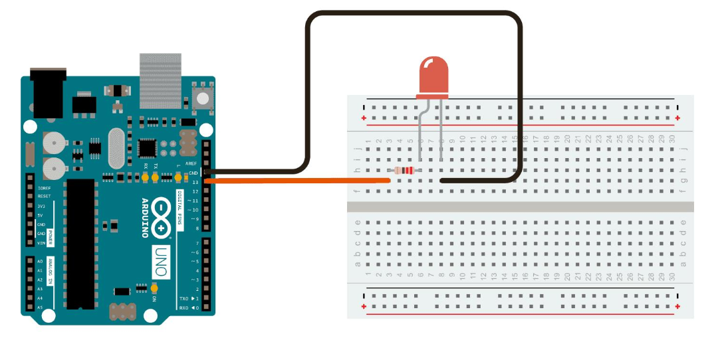
- Puss Button LED

Components
- Arduino Uno
- LED
- 220Ω Resistor (for LED)
- Push Button
- 10kΩ Resistor (pull-down)
- Breadboard
- Jumper Wires
Connections
Power Connections
- Arduino 5V → Breadboard + rail
- Arduino GND → Breadboard – rail
LED Connections
- Pin 13 → 220Ω Resistor → LED Anode (long leg)
- LED Cathode (short leg) → GND
Push Button Connections
- One side of button → 5V
- Other side → Pin 2 (green wire)
- 10kΩ Resistor → between Pin 2 and GND (pull-down resistor)
Code
int buttonPin = 2;
int ledPin = 13;
int buttonState = 0;
void setup() {
pinMode(ledPin, OUTPUT);
pinMode(buttonPin, INPUT);
}
void loop() {
buttonState = digitalRead(buttonPin);
if (buttonState == HIGH) {
digitalWrite(ledPin, HIGH); // LED ON
} else {
digitalWrite(ledPin, LOW); // LED OFF
}
}
Working
- When button is pressed, Pin 2 gets HIGH (5V)
- Arduino detects HIGH → turns LED ON
- When button is released, pull-down resistor makes Pin 2 LOW
- Arduino turns LED OFF

Reference Image
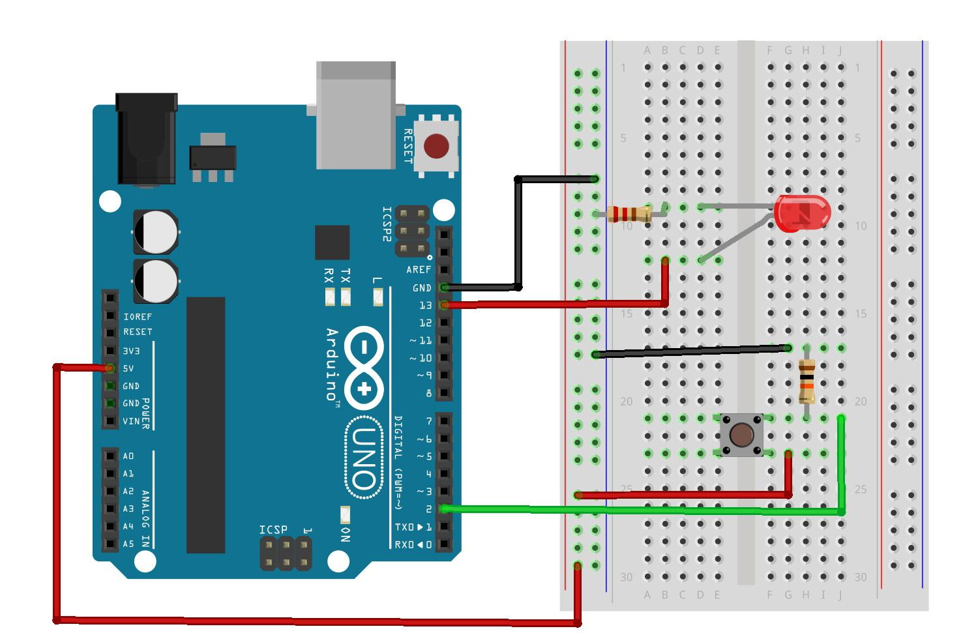

LDR Light Sensor

Components
- Arduino Uno
- LED
- LDR (Light Dependent Resistor)
- 220Ω Resistor (for LED)
- 10kΩ Resistor (for LDR voltage divider)
- Breadboard
- Jumper Wires
Connections
Power
- Arduino 5V → Breadboard + rail
- Arduino GND → Breadboard – rail
LED Connection
- Pin 9 → 220Ω Resistor → LED Anode (long leg)
- LED Cathode → GND
LDR Connection (Voltage Divider)
- One leg of LDR → 5V
- Other leg of LDR → Analog Pin A0
- 10kΩ Resistor → between A0 and GND
This forms a voltage divider circuit
Code
int ldrPin = A0;
int ledPin = 9;
int ldrValue = 0;
void setup() {
pinMode(ledPin, OUTPUT);
Serial.begin(9600);
}
void loop() {
ldrValue = analogRead(ldrPin); // read light value
Serial.println(ldrValue);
if (ldrValue < 500) { // Dark condition
digitalWrite(ledPin, HIGH); // LED ON
} else {
digitalWrite(ledPin, LOW); // LED OFF
}
delay(100);
}
Working
- LDR changes resistance based on light
- Bright light → Low resistance → Higher voltage at A0
- Dark → High resistance → Lower voltage at A0
Arduino reads this value:
- If dark → LED ON
- If bright → LED OFF

Reference Image

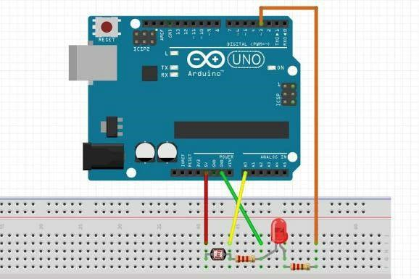

Buzzer Beep

Components Used
- Arduino Uno
- Buzzer (Active buzzer)
- Breadboard
- Jumper Wires
Pin Connections (as per image)

Power Connections
- Arduino GND → Buzzer Negative (- pin)

Buzzer Connection
- Arduino Pin 4 → Buzzer Positive (+ pin)
- Red wire → Pin 4 (signal)
Black wire → GND
Code
int buzzerPin = 4;
void setup() {
pinMode(buzzerPin, OUTPUT);
}
void loop() {
digitalWrite(buzzerPin, HIGH); // Buzzer ON
delay(1000);

digitalWrite(buzzerPin, LOW); // Buzzer OFF
delay(1000);
}
Working
- Arduino sends HIGH signal to buzzer → it produces sound
- Arduino sends LOW signal → buzzer stops
- This repeats → beep ON/OFF every 1 second
Reference Image
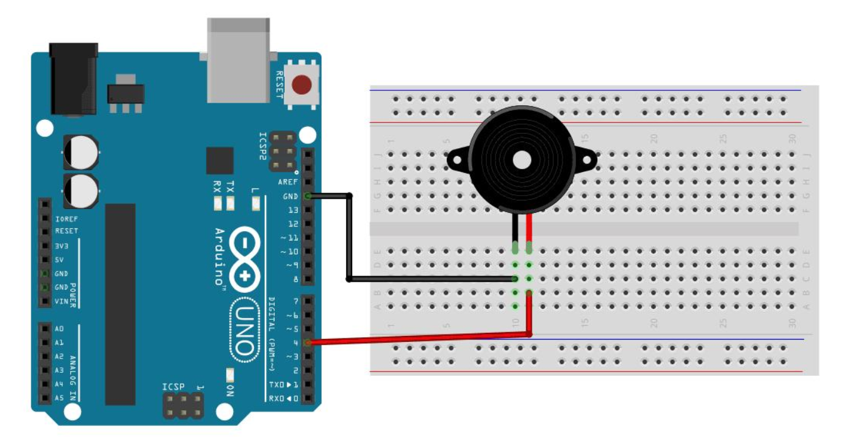

4. RGB LED Color Control using Potentiometer

Components Required
- Arduino Uno R3
- RGB LED (Common Cathode recommended)
- 3 × 220Ω Resistors
- 1 × 10kΩ Potentiometer
- Breadboard
- Jumper Wires
Connections
RGB LED Connections:
- Red pin → Arduino PWM pin 9 (via 220Ω resistor)
- Green pin → Arduino PWM pin 10 (via 220Ω resistor)
- Blue pin → Arduino PWM pin 11 (via 220Ω resistor)
- Common Cathode → GND
Potentiometer Connections:
- One side → 5V
- Other side → GND
- Middle pin (wiper) → Analog pin A0
Code
int potPin = A0;
int redPin = 9;
int greenPin = 10;
int bluePin = 11;
void setup() {
pinMode(redPin, OUTPUT);
pinMode(greenPin, OUTPUT);
pinMode(bluePin, OUTPUT);
}
void loop() {
int potValue = analogRead(potPin);
int redValue = map(potValue, 0, 1023, 0, 255);
int greenValue = map(potValue, 0, 1023, 255, 0);
int blueValue = map(potValue, 0, 1023, 128, 255);
analogWrite(redPin, redValue);
analogWrite(greenPin, greenValue);
analogWrite(bluePin, blueValue);
delay(10);
}
Working Explanation
- The potentiometer acts like a variable voltage divider, giving different analog values (0–1023).
- The Arduino Uno R3 reads this value and converts it into PWM signals (0–255).
- These PWM signals control the brightness of Red, Green, and Blue pins.
- By turning the knob, you change intensity combinations → resulting in different colors.
Reference Image
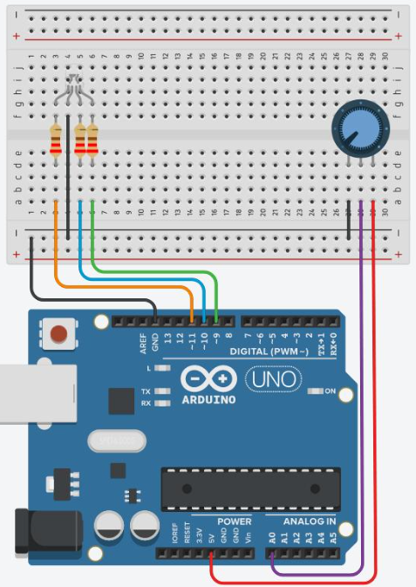

Ultrasonic Distance Indicator (HC-SR04 + LED/Buzzer)

Components
- Arduino Uno R3
- HC-SR04 Ultrasonic Sensor
- LED (any color)
- 220Ω Resistor
- Buzzer (Active/Passive)
- Breadboard
- Jumper Wires

Connections
Ultrasonic Sensor (HC-SR04):
- VCC → 5V
- GND → GND
- TRIG → Pin 9
- ECHO → Pin 10
LED Connections:
- Anode (+) → Pin 6 (via 220Ω resistor)
- Cathode (–) → GND
Buzzer Connections:
- Positive (+) → Pin 7
- Negative (–) → GND

Arduino Code
#define trigPin 9
#define echoPin 10
#define ledPin 6
#define buzzer 7
long duration;
int distance;
void setup() {
pinMode(trigPin, OUTPUT);
pinMode(echoPin, INPUT);
pinMode(ledPin, OUTPUT);
pinMode(buzzer, OUTPUT);
Serial.begin(9600);
}
void loop() {
digitalWrite(trigPin, LOW);
delayMicroseconds(2);

digitalWrite(trigPin, HIGH);
delayMicroseconds(10);
digitalWrite(trigPin, LOW);
duration = pulseIn(echoPin, HIGH);
distance = duration * 0.034 / 2;
Serial.print("Distance: ");
Serial.println(distance);
if (distance < 20) {
digitalWrite(ledPin, HIGH);
digitalWrite(buzzer, HIGH);
} else {
digitalWrite(ledPin, LOW);
digitalWrite(buzzer, LOW);
}
delay(100);
}

Working Explanation
- The HC-SR04 Ultrasonic Sensor sends ultrasonic waves and receives the echo back.
- The Arduino Uno R3 calculates distance using time taken by the echo.
- If an object is closer than 20 cm, the LED glows and buzzer turns ON.
- If the object is far, both remain OFF.
Reference Image
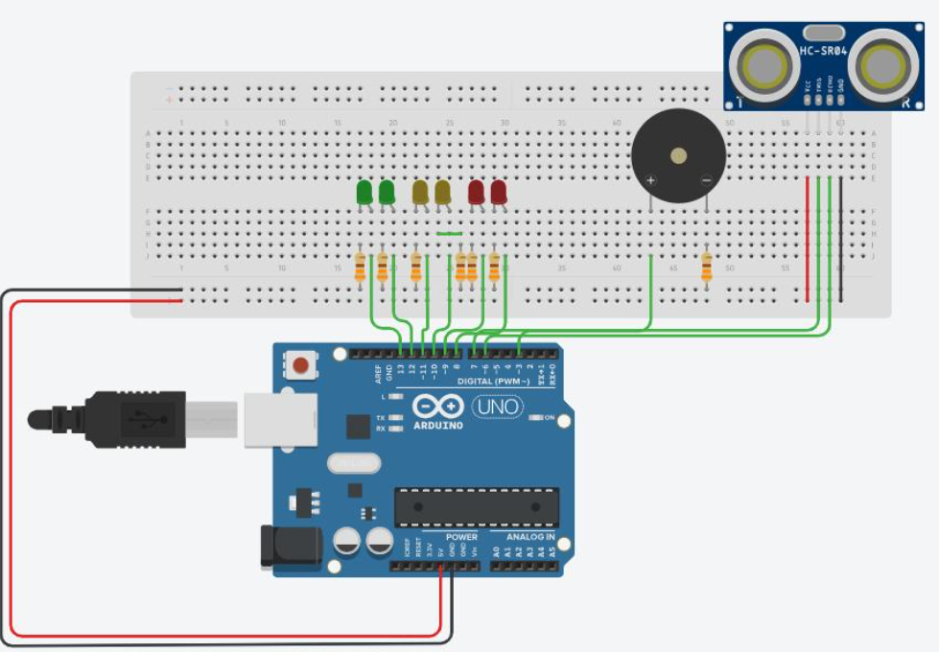

- Temperature Display using DHT11 (Arduino)

Components
- Arduino Uno R3
- DHT11 Temperature and Humidity Sensor
- 10kΩ Resistor (pull-up)
- Breadboard
- Jumper Wires
- 16x2 LCD Display

Connections
DHT11 Sensor:
- VCC → 5V
- GND → GND
- DATA → Pin 2
- 10kΩ resistor between VCC and DATA (pull-up)
LCD 16x2:
- VCC → 5V
- GND → GND
- SDA → A4
- SCL → A5

Code
#include <DHT.h>
#include <Wire.h>
#include <LiquidCrystal_I2C.h>
#define DHTPIN 2
#define DHTTYPE DHT11

DHT dht(DHTPIN, DHTTYPE);
LiquidCrystal_I2C lcd(0x27, 16, 2);
void setup() {
lcd.begin();
lcd.backlight();
dht.begin();
}
void loop() {
float temp = dht.readTemperature();
float hum = dht.readHumidity();

lcd.clear();
lcd.setCursor(0, 0);
lcd.print("Temp: ");
lcd.print(temp);
lcd.print(" C");
lcd.setCursor(0, 1);
lcd.print("Hum: ");
lcd.print(hum);
lcd.print(" %");
delay(2000);
}

Working
- The DHT11 Temperature and Humidity Sensor measures temperature and humidity using internal sensing elements.
- It sends digital data to the Arduino Uno R3 through the DATA pin.
- Arduino processes this data and displays it on Serial Monitor or LCD.
- The values update every 2 seconds for real-time monitoring.
Reference
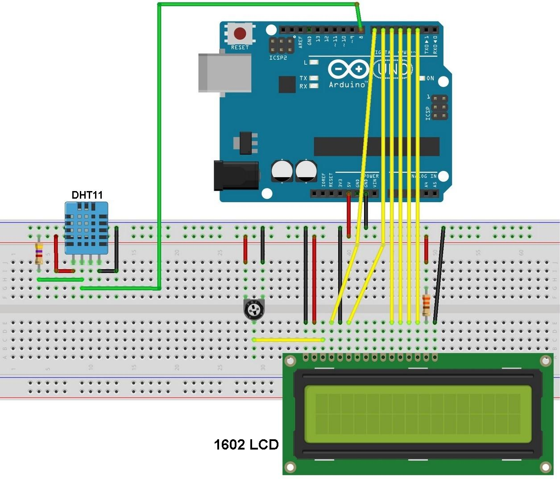

- Automatic Street Light using LDR (Arduino)

Components Required

Arduino Uno R3

LDR (Light Dependent Resistor)

10kΩ Resistor

LED

220Ω Resistor

Breadboard

Jumper Wires

Pin Connections

LDR Circuit (Voltage Divider)

One side of LDR → 5V

Other side of LDR → Analog Pin A0

10kΩ resistor between A0 and GND

LED Circuit

LED Anode (+) → Digital Pin 7 (via 220Ω resistor)

LED Cathode (–) → GND

Code

int ldrPin = A0;

int ledPin = 7;

int threshold = 500; // adjust based on light condition

void setup() {

pinMode(ledPin, OUTPUT);

Serial.begin(9600);

}

void loop() {

int ldrValue = analogRead(ldrPin);

Serial.println(ldrValue);

if (ldrValue < threshold) {

digitalWrite(ledPin, HIGH); // Dark → LED ON

} else {

digitalWrite(ledPin, LOW); // Light → LED OFF

}

delay(200);

}

Working

The LDR changes resistance based on light intensity (low resistance in light, high in dark).

A voltage divider converts this change into an analog voltage read by the Arduino Uno R3.

When it gets dark, the analog value drops below a threshold → LED turns ON.

In bright light, value increases → LED turns OFF automatically.

Reference Image
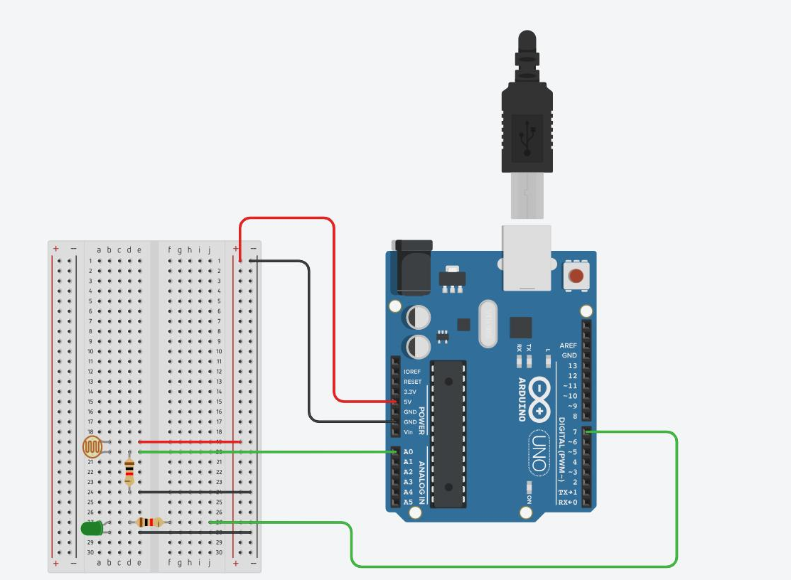

IR Sensor Object Detection

Components Required
- Arduino Uno R3
- IR Sensor Module (Obstacle Detection)
- LED
- 220Ω Resistor
- Buzzer (optional)
- Breadboard
- Jumper Wires
Pin Connections

IR Sensor Module
- VCC → 5V
- GND → GND
- OUT → Digital Pin 2

LED Connection
- Anode (+) → Pin 7 (via 220Ω resistor)
- Cathode (–) → GND

Buzzer (Optional)
- Positive (+) → Pin 8
- Negative (–) → GND
Arduino Code
int sensorPin = 2;
int ledPin = 7;
int buzzerPin = 8;

void setup() {
pinMode(sensorPin, INPUT);
pinMode(ledPin, OUTPUT);
pinMode(buzzerPin, OUTPUT);
Serial.begin(9600);
}

void loop() {
int sensorValue = digitalRead(sensorPin);
Serial.println(sensorValue);

if (sensorValue == LOW) { // Object detected
digitalWrite(ledPin, HIGH);
digitalWrite(buzzerPin, HIGH);
} else {
digitalWrite(ledPin, LOW);
digitalWrite(buzzerPin, LOW);
}

delay(100);
}

Working
- The IR sensor emits infrared light and detects reflection from nearby objects.
- When an object comes close, the sensor output becomes LOW.
- The Arduino Uno R3 reads this signal and turns ON the LED and buzzer.
- When no object is present, output stays HIGH → LED and buzzer remain OFF.
Reference Image
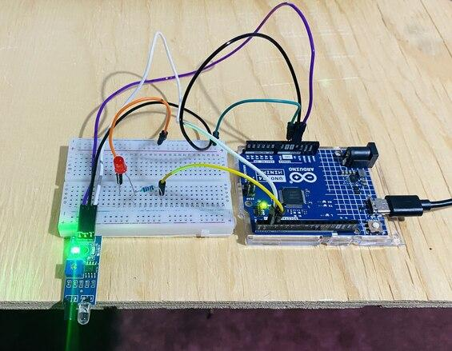

- PIR Motion Detection Alarm

Components
- Arduino Uno R3
- PIR Motion Sensor (e.g., HC-SR501)
- Buzzer
- LED (optional)
- 220Ω Resistor
- Breadboard
- Jumper Wires
Connections

PIR Sensor (HC-SR501)
- VCC → 5V
- GND → GND
- OUT → Digital Pin 2

Buzzer Connection
- Positive (+) → Pin 8
- Negative (–) → GND

LED (Optional)
- Anode (+) → Pin 7 (via 220Ω resistor)
- Cathode (–) → GND
Code
int pirPin = 2;
int buzzer = 8;
int ledPin = 7;

void setup() {
pinMode(pirPin, INPUT);
pinMode(buzzer, OUTPUT);
pinMode(ledPin, OUTPUT);
Serial.begin(9600);
}

void loop() {
int motion = digitalRead(pirPin);

if (motion == HIGH) {
Serial.println("Motion Detected!");
digitalWrite(buzzer, HIGH);
digitalWrite(ledPin, HIGH);
} else {
Serial.println("No Motion");
digitalWrite(buzzer, LOW);
digitalWrite(ledPin, LOW);
}

delay(200);
}

Working Explanation
- The PIR sensor detects infrared radiation changes caused by human movement.
- When motion is detected, the sensor output becomes HIGH.
- The Arduino Uno R3 reads this signal and activates the buzzer and LED.
- When no motion is present, the alarm remains OFF.
Reference Image
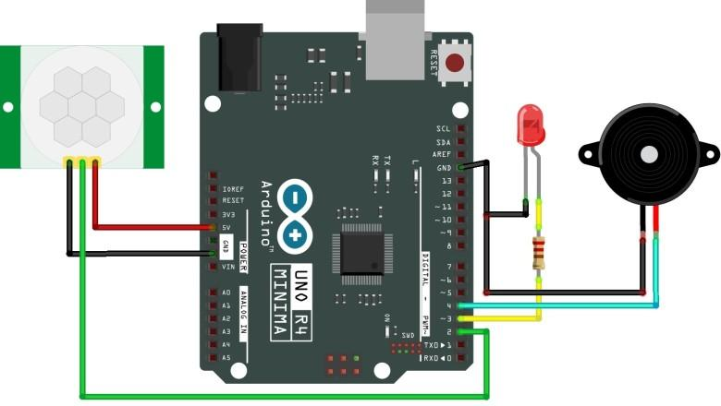

- Soil Moisture Plant Monitor

Components Required
- Arduino Uno R3
- Soil Moisture Sensor Module
- LED
- 220Ω Resistor
- Buzzer (optional)
- Breadboard
- Jumper Wires
Connections

Soil Moisture Sensor
- VCC → 5V
- GND → GND
- AO (Analog Output) → A0

LED Connection
- Anode (+) → Pin 7 (via 220Ω resistor)
- Cathode (–) → GND

Buzzer (Optional)
- Positive (+) → Pin 8
- Negative (–) → GND
Code
int sensorPin = A0;
int ledPin = 7;
int buzzerPin = 8;

void setup() {
pinMode(ledPin, OUTPUT);
pinMode(buzzerPin, OUTPUT);
Serial.begin(9600);
}

void loop() {
int moistureValue = analogRead(sensorPin);
Serial.println(moistureValue);

if (moistureValue > 600) { // Dry soil (adjust value)
digitalWrite(ledPin, HIGH);
digitalWrite(buzzerPin, HIGH);
} else {
digitalWrite(ledPin, LOW);
digitalWrite(buzzerPin, LOW);
}

delay(500);
}

Working
- The soil moisture sensor measures water content in soil based on conductivity.
- Dry soil gives higher analog values, wet soil gives lower values.
- The Arduino Uno R3 reads this value from analog pin A0.
- When soil is dry (above threshold), LED and buzzer turn ON as an alert.
Reference Image
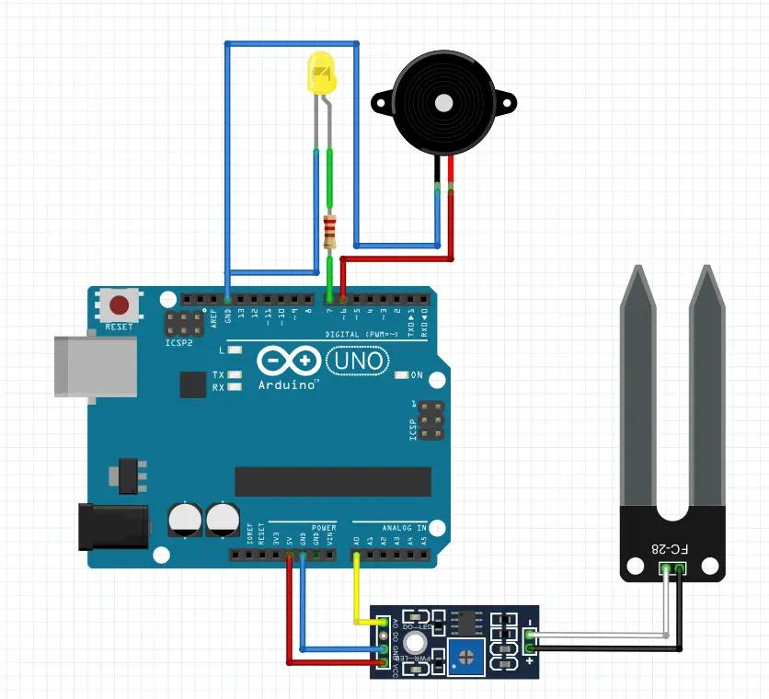

- Gas Leakage Detection using MQ-2 (Arduino)

Components
- Arduino Uno R3
- MQ-2 Gas Sensor Module
- LED
- 220Ω Resistor
- Buzzer
- Breadboard
- Jumper Wires
Connections

MQ-2 Gas Sensor
- VCC → 5V
- GND → GND
- AO → A0 (for analog reading)
(or DO → Pin 2 for digital detection)

LED Connection
- Anode (+) → Pin 7 (via 220Ω resistor)
- Cathode (–) → GND

Buzzer Connection
- Positive (+) → Pin 8
- Negative (–) → GND
Code
int gasPin = A0;
int ledPin = 7;
int buzzerPin = 8;

void setup() {
pinMode(ledPin, OUTPUT);
pinMode(buzzerPin, OUTPUT);
Serial.begin(9600);
}

void loop() {
int gasValue = analogRead(gasPin);
Serial.println(gasValue);

if (gasValue > 400) { // Threshold (adjust as needed)
digitalWrite(ledPin, HIGH);
digitalWrite(buzzerPin, HIGH);
} else {
digitalWrite(ledPin, LOW);
digitalWrite(buzzerPin, LOW);
}

delay(200);
}

Working
- The MQ-2 Gas Sensor Module detects gases like LPG, methane, smoke, etc.
- It outputs an analog voltage based on gas concentration.
- The Arduino Uno R3 reads this value from A0.
- When gas level exceeds a set threshold, the LED glows and buzzer sounds an alarm.
Reference Image
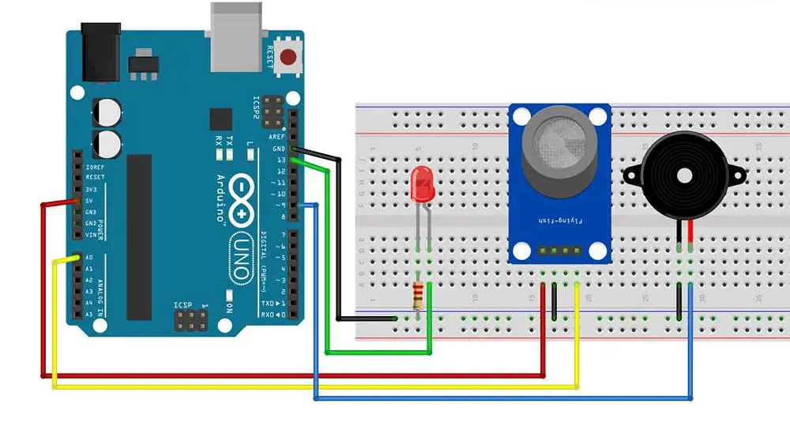

Rain Detection System

Components Required
- Arduino Uno R3
- Rain Sensor Module (YL-83 / FC-37)
- LED
- 220Ω Resistor
- Buzzer
- Breadboard
- Jumper Wires
Connections

Rain Sensor Module
- VCC → 5V
- GND → GND
- AO → A0 (Analog output for intensity)
(or DO → Pin 2 for digital detection)

LED Connection
- Anode (+) → Pin 7 (via 220Ω resistor)
- Cathode (–) → GND

Buzzer Connection
- Positive (+) → Pin 8
- Negative (–) → GND
Code
int rainPin = A0;
int ledPin = 7;
int buzzerPin = 8;

void setup() {
pinMode(ledPin, OUTPUT);
pinMode(buzzerPin, OUTPUT);
Serial.begin(9600);
}

void loop() {
int rainValue = analogRead(rainPin);
Serial.println(rainValue);

if (rainValue < 500) { // Rain detected (adjust threshold)
digitalWrite(ledPin, HIGH);
digitalWrite(buzzerPin, HIGH);
} else {
digitalWrite(ledPin, LOW);
digitalWrite(buzzerPin, LOW);
}

delay(200);
}

Working
- The rain sensor detects water droplets on its surface.
- When rain falls, conductivity increases → analog value changes.
- The Arduino Uno R3 reads this value from A0.
- If water is detected (value below threshold), LED and buzzer turn ON.
Reference Image
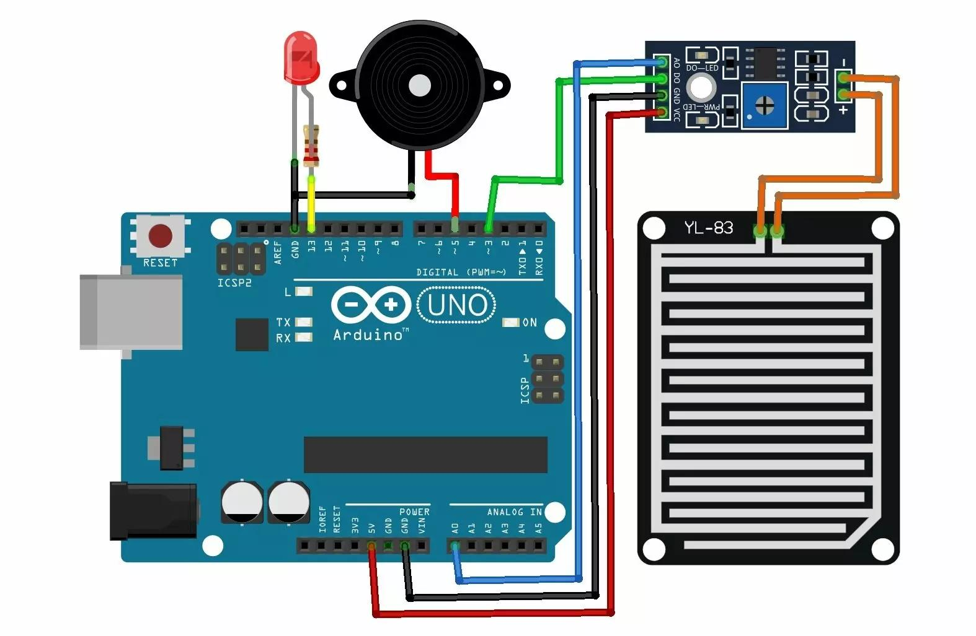

Touch Sensor LED Control

Components
- Arduino Uno R3
- Touch Sensor Module (e.g., TTP223 Capacitive Touch)
- LED
- 220Ω Resistor
- Breadboard
- Jumper Wires

Connections

Touch Sensor Module
- VCC → 5V
- GND → GND
- OUT → Digital Pin 2

LED Connection
- Anode (+) → Pin 7 (via 220Ω resistor)
- Cathode (–) → GND
Code
int touchPin = 2;
int ledPin = 7;

int ledState = LOW;
int lastTouchState = LOW;

void setup() {
pinMode(touchPin, INPUT);
pinMode(ledPin, OUTPUT);
Serial.begin(9600);
}

void loop() {
int touchValue = digitalRead(touchPin);

if (touchValue == HIGH && lastTouchState == LOW) {
ledState = !ledState; // Toggle LED
digitalWrite(ledPin, ledState);
delay(200); // debounce
}

lastTouchState = touchValue;
}

Working
- The touch sensor detects human touch using capacitance.
- When touched, it outputs a HIGH signal.
- The Arduino Uno R3 reads this signal and toggles the LED state.
- Each touch acts like a switch → ON/OFF control.
Reference Image
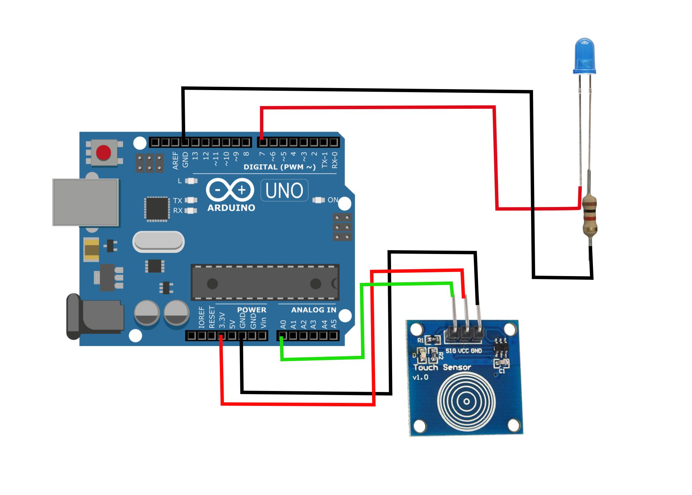

- Servo Motor (SG90) with Arduino

Components
- Arduino Uno R3
- SG90 Servo Motor
- Jumper Wires
Connections

Servo Motor Pins
- Red (VCC) → 5V (Arduino)
- Brown/Black (GND) → GND (Arduino)
- Orange/Yellow (Signal) → Digital Pin 9

Simple Arduino Code
#include <Servo.h>

Servo myServo;

void setup() {
myServo.attach(9); // Signal pin
}

void loop() {
myServo.write(0); // 0 degree
delay(2000);

myServo.write(90); // 90 degree
delay(2000);

myServo.write(180); // 180 degree
delay(2000);
}

Working
The Arduino Uno R3 sends PWM signals to the servo.
The SG90 Servo Motor rotates to specific angles (0°–180°).
It moves step-by-step between positions based on the code.

- Automatic Door Opening System using PIR Sensor & Servo

Components
- Arduino Uno R3
- PIR Motion Sensor (HC-SR501)
- SG90 Servo Motor
- Jumper Wires
- Breadboard (optional)
- External 5V supply (recommended for servo)
Connections

PIR Sensor
- VCC → 5V
- GND → GND
- OUT → Digital Pin 2

Servo Motor
- Red (VCC) → 5V
- Brown/Black (GND) → GND
- Orange/Yellow (Signal) → Digital Pin 9
Code
#include <Servo.h>

int pirPin = 2;
int motionState = 0;

Servo doorServo;

void setup() {
pinMode(pirPin, INPUT);
doorServo.attach(9);
doorServo.write(0); // Door closed initially
Serial.begin(9600);
}

void loop() {
motionState = digitalRead(pirPin);

if (motionState == HIGH) {
Serial.println("Motion Detected - Door Opening");
doorServo.write(90); // Open door
delay(3000); // Keep door open
} else {
Serial.println("No Motion - Door Closed");
doorServo.write(0); // Close door
}

delay(200);
}

Working Procedure
- The PIR sensor continuously monitors infrared radiation changes (human movement).
- When a person comes near, the PIR sensor outputs a HIGH signal.
- The Arduino Uno R3 reads this signal.
- Arduino sends a command to the SG90 Servo Motor.
- The servo rotates to 90° → door opens.
- After a delay, or when no motion is detected, the servo returns to 0° → door closes.
Reference Image
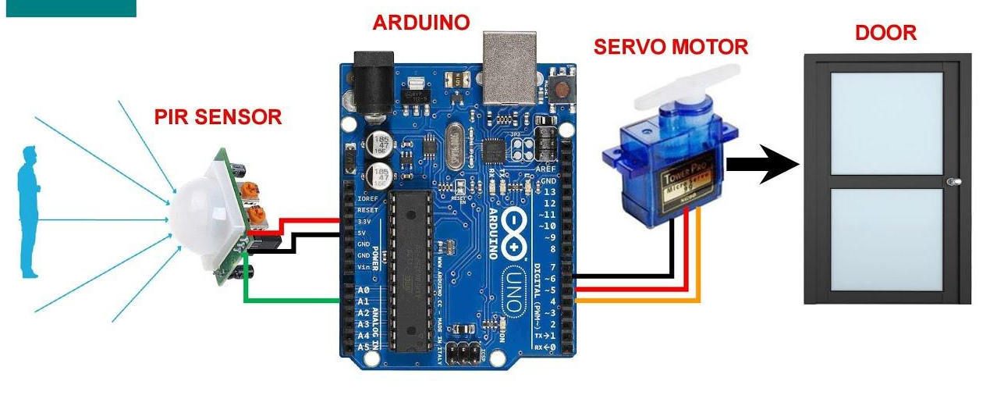

16. Ultrasonic Servo Control System

Components
- Arduino Uno R3
- HC-SR04 Ultrasonic Sensor
- SG90 Servo Motor
- Jumper Wires
- Breadboard
Connections

Ultrasonic Sensor (HC-SR04)
- VCC → 5V
- GND → GND
- TRIG → Pin 9
- ECHO → Pin 10

Servo Motor (SG90)
- Red (VCC) → 5V
- Brown/Black (GND) → GND
- Orange/Yellow (Signal) → Pin 6
Basic Arduino Code (Servo + Distance)
#include <Servo.h>

#define trigPin 9
#define echoPin 10

Servo myServo;

long duration;
int distance;

void setup() {
myServo.attach(6);
pinMode(trigPin, OUTPUT);
pinMode(echoPin, INPUT);
Serial.begin(9600);
}

void loop() {
// Ultrasonic trigger
digitalWrite(trigPin, LOW);
delayMicroseconds(2);
digitalWrite(trigPin, HIGH);
delayMicroseconds(10);
digitalWrite(trigPin, LOW);

duration = pulseIn(echoPin, HIGH);
distance = duration * 0.034 / 2;

Serial.print("Distance: ");
Serial.println(distance);

// Servo control based on distance
if (distance < 20) {
myServo.write(90); // turn
} else {
myServo.write(0); // reset
}

delay(200);
}
Working
- The HC-SR04 Ultrasonic Sensor measures distance using sound waves.
- The Arduino Uno R3 calculates the distance.
- If an object is close, the SG90 Servo Motor rotates.
- If no object is near, servo returns to its original position.

Reference Image
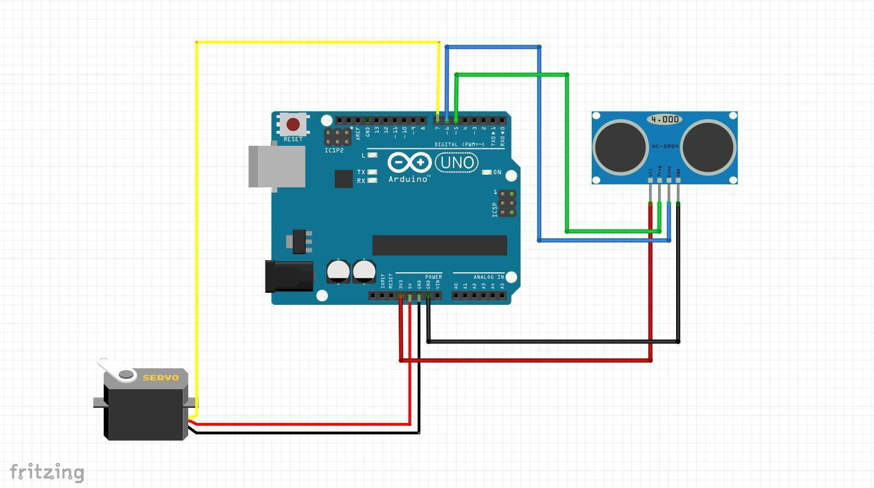

17.Automatic Irrigation System using Soil Moisture Sensor

Components Required
- Arduino Uno R3
- Soil Moisture Sensor Module
- Relay Module
- Water Pump
- 16x2 LCD Display with I2C (or normal LCD as in image)
- Breadboard
- Jumper Wires
- 9V Battery + Clip
Pin Connections

Soil Moisture Sensor
- VCC → 5V
- GND → GND
- AO → A0
Relay Module
- VCC → 5V
- GND → GND
- IN → Pin 7
Water Pump (via Relay)
- Battery (+) → Relay COM
- Relay NO → Pump (+)
- Pump (–) → Battery (–)
LCD (I2C Version)
- VCC → 5V
- GND → GND
- SDA → A4
- SCL → A5
Code
#include <Wire.h>
#include <LiquidCrystal_I2C.h>
LiquidCrystal_I2C lcd(0x27, 16, 2);
int sensorPin = A0;
int relayPin = 7;
void setup() {
pinMode(relayPin, OUTPUT);
lcd.begin();
lcd.backlight();
Serial.begin(9600);
}
void loop() {
int moisture = analogRead(sensorPin);
Serial.println(moisture);
lcd.setCursor(0, 0);
lcd.print("Moisture: ");
lcd.print(moisture);
if (moisture > 600) {
digitalWrite(relayPin, LOW); // Pump ON
lcd.setCursor(0, 1);
lcd.print("PUMP ON ");
} else {
digitalWrite(relayPin, HIGH); // Pump OFF
lcd.setCursor(0, 1);
lcd.print("PUMP OFF");
}
delay(1000);
}
Working Explanation
- The soil moisture sensor detects water content in soil.
- It sends analog values to the Arduino Uno R3.
- If soil is dry (high value):
  - Relay activates
  - Water pump turns ON
  - LCD shows “PUMP ON”
- If soil is wet (low value):
  - Pump turns OFF
  - LCD shows “PUMP OFF”

Arduino Kit Components
1 x Arduino Uno R3 (ATmega328, 5V, 16MHz, 32KB Flash)
1 x USB Cable (Type-A to Type-B, 20cm)
1 x Breadboard (170 Pins, Self-Adhesive)
90 x Jumper Wires (M-M, M-F, F-F, 20cm)
1 x Resistor Kit (30 Values)
10 x LEDs (Red, Green, Blue, White, Yellow, RGB, 3mm) 3 x RGB LED
3 x Push Buttons (4-Pin Tactile)
1 x Potentiometer (10K Ohm)
1 x Buzzer (6V–12V, 2.8 kHz)
1 x Ultrasonic Sensor (HC-SR04, 2–400 cm)
1 x Temperature Sensor (DHT11, 0–50°C, Humidity 20–90%)
1 x LDR Light Sensor (3.3–5V)
1 x IR Sensor Module (LM393, 3.3–5V)
1 x PIR Motion Sensor (HCSR501)
1 x Soil Moisture Sensor (3.3–5V)
1 x Gas Sensor (Analog + Digital Output, 5V)
1 x Sound Sensor (LM393, 3.3–5V)
1 x Rain Drop Sensor (LM393, 5V)
1 x Touch Sensor (2–5.5V)
1 x Water Pump (3.3–6V, 80–120 L/H)
1 x Water Flow Sensor (YF-S201, Hall Effect)
1 x Relay Module (10A Switching)

1 x Servo Motor (SG90, 3–7.2V)
1 x DC Motor (3–6V)
1 x Fan Module (Plastic)
2 x Wheels (65mm, Rubber)
1 x Caster Wheel
1 x 16x2 LCD Display with I2C (0x27, 5V)
1 x TM1637 4-Digit 7 Segment Display
2 x 9V Batteries
1 x 9V Battery Clip

1 x Clip with DC Jack

